**Ideation Phase**

**Empathize & Discover**

|  |  |
| --- | --- |
| Date | 26 June 2025 |
| Team ID | LTVIP2025TMID20451 |
| Project Name | EduTutor AI: Personalized Learning with Generative AI and LMS Integration |
| Maximum Marks | 4 Marks |

**Empathy Map Canvas:**

* **Says**: “I need practice on what I find hardest.”
* **Thinks**: “Am I falling behind my classmates?”
* **Does**: Skips exercises that feel too easy; gets discouraged by repeated failures.
* **Feels**: Frustrated when quiz questions don’t match what was taught; anxious without

feedback.

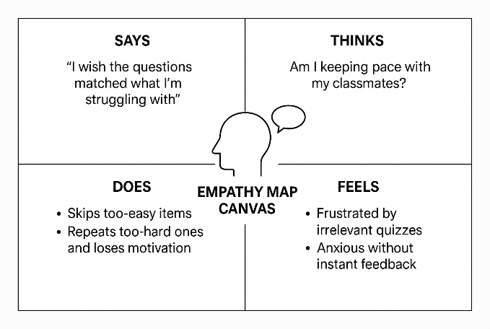

Reference: <https://www.mural.co/templates/empathy-map-canvas>